# “Hello, World!” Tutorial for Java

**Purpose:** This manual instructs novice Java programmers on how to create their own “Hello, World!” program using an IDE.

Table of Contents

Installing an IDE ………………………………2

Setting Up the Environment……………3

Programming “Hello, World!” ………….4

Installing an IDE

An IDE (Integrated Development Environment) compiles all the basic tools to develop and test software into a single GUI (graphical user interface). IDEs increase productivity by warning users of errors through syntax highlighting, autocompleting lines of code, building executables for certain languages, and providing tools for debugging in order to inspect code. All these features streamline the coding process and are helpful for programmers of all kinds, both novices and experts alike.

Each programming language has its own specific pool of IDEs. The most commonly used for Java are: [Eclipse](https://www.eclipse.org/downloads/), [IntelliJ](https://www.jetbrains.com/idea/download/#section=windows), and [Microsoft Visual Studio](https://visualstudio.microsoft.com/) through the use of add-ons. This tutorial will be using IntelliJ.

1. Download the specific version based on your OS. (Windows, Mac, Linux)
2. During the installation process, leave the installation destination as the default.
3. Next, for installation options: check .java for Create Associations, and add bin folder to path so the environment path is set automatically during installation.
4. The JetBrains folder will be created once installation has finished.
5. Finally a window will appear asking you to pick between config or installation directory or do not import settings. Select the latter option as there is nothing to import currently.

After the final step, you should now have IntelliJ properly set up and ready for programming.

Setting Up the Environment

“Hello, World,” is the first program programmers often start with, a simple program that only outputs the phrase “Hello, World!” It is designed to introduce novice programmers to the basics of programming: printing statements, familiarizing yourself with IDEs, and understanding basic syntax of a language.

1. Create a new project. Click file on the top left, drag your mouse down to new, and then click project.
2. Then you will be taken to a new window asking you about what additional libraries to use, select both Groovy and Kotlin/JVM.
3. Name the project, usually name your projects with relevance towards the goal of your project, but for now name it helloworld.
4. Click helloworld, right click src, and select Java class.
5. You will be asked to name the Java class, which is different from naming the project, name it helloworldcode.

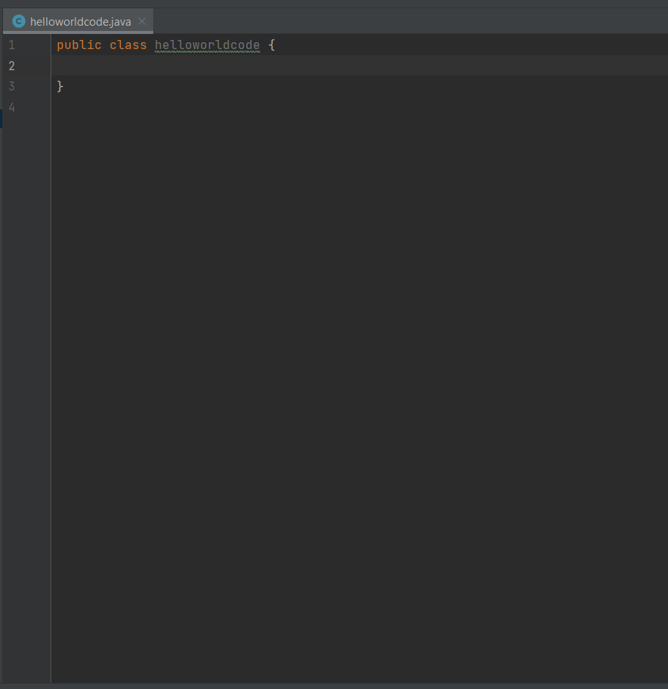

This is the area where you will do most of your coding.

Programming “Hello, World!”

1. Before starting to code properly, you must have a main method. Type in main() and the IDE’s autocomplete feature will fill the rest out for you. Without the main method, the code cannot run.

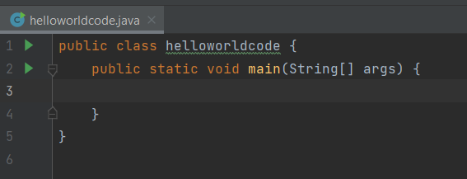

1. Between the curly braces for the main method, type out System.out.println(); this line of code will be used to print text.
2. Within the parentheses, type in a pair of quotation marks. This is where we will print out the “Hello, World!” statement.
3. Type in “Hello, World!” between the quotation marks.

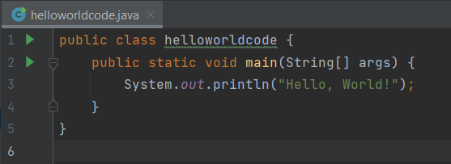

Prior to running your code, take advantage of IntelliJ’s syntax highlighting to detect any errors. As long as there is at least one error, your program will never run. Typical mistakes include writing your statement outside of the main class, or syntax errors with your print statement. Once your code is clean of errors, run the program by right clicking helloworldcode, or clicking the run button to the left of the code. Your output will show up in a new window on the bottom.

